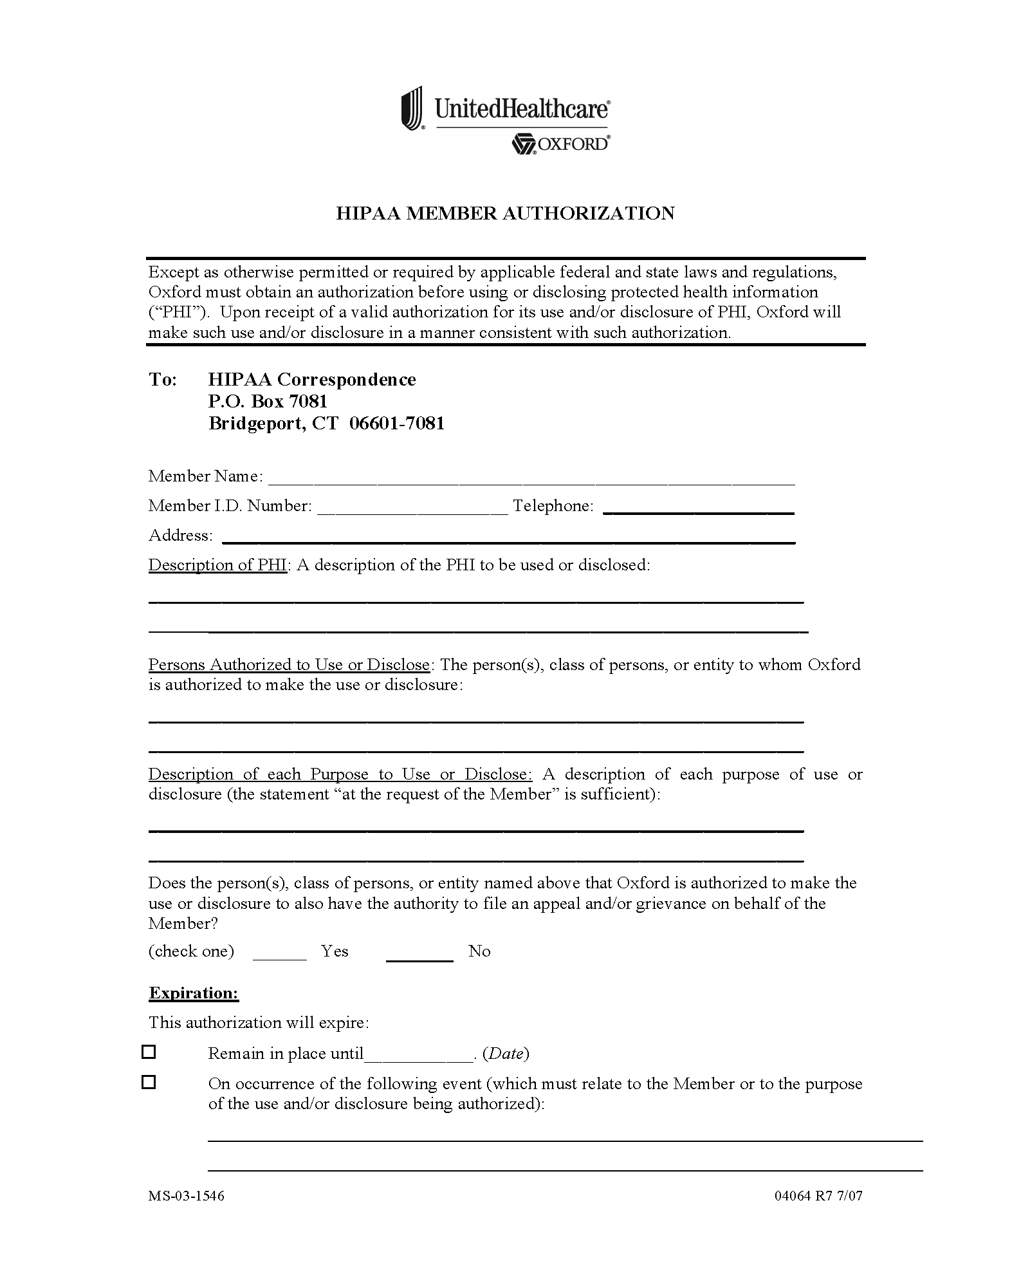
Cody Zunda, a minor
3610 Windmill Dr. Waterford, MI 48329, Apt 124

FROM 08/12/1997 TO PRESENT: Any and all MEDICAL RECORDS pertaining to Cody Zunda, a minor SSN: , DOB: 08/12/1997.
Christopher P. Dinverno, Axiom Requisition Copy Service, 447 North Canal Road,

Lansing, Michigan 48917 (877) 886-5090 / (517) 886-4116 Fax
Legal Discovery
01-19228-005
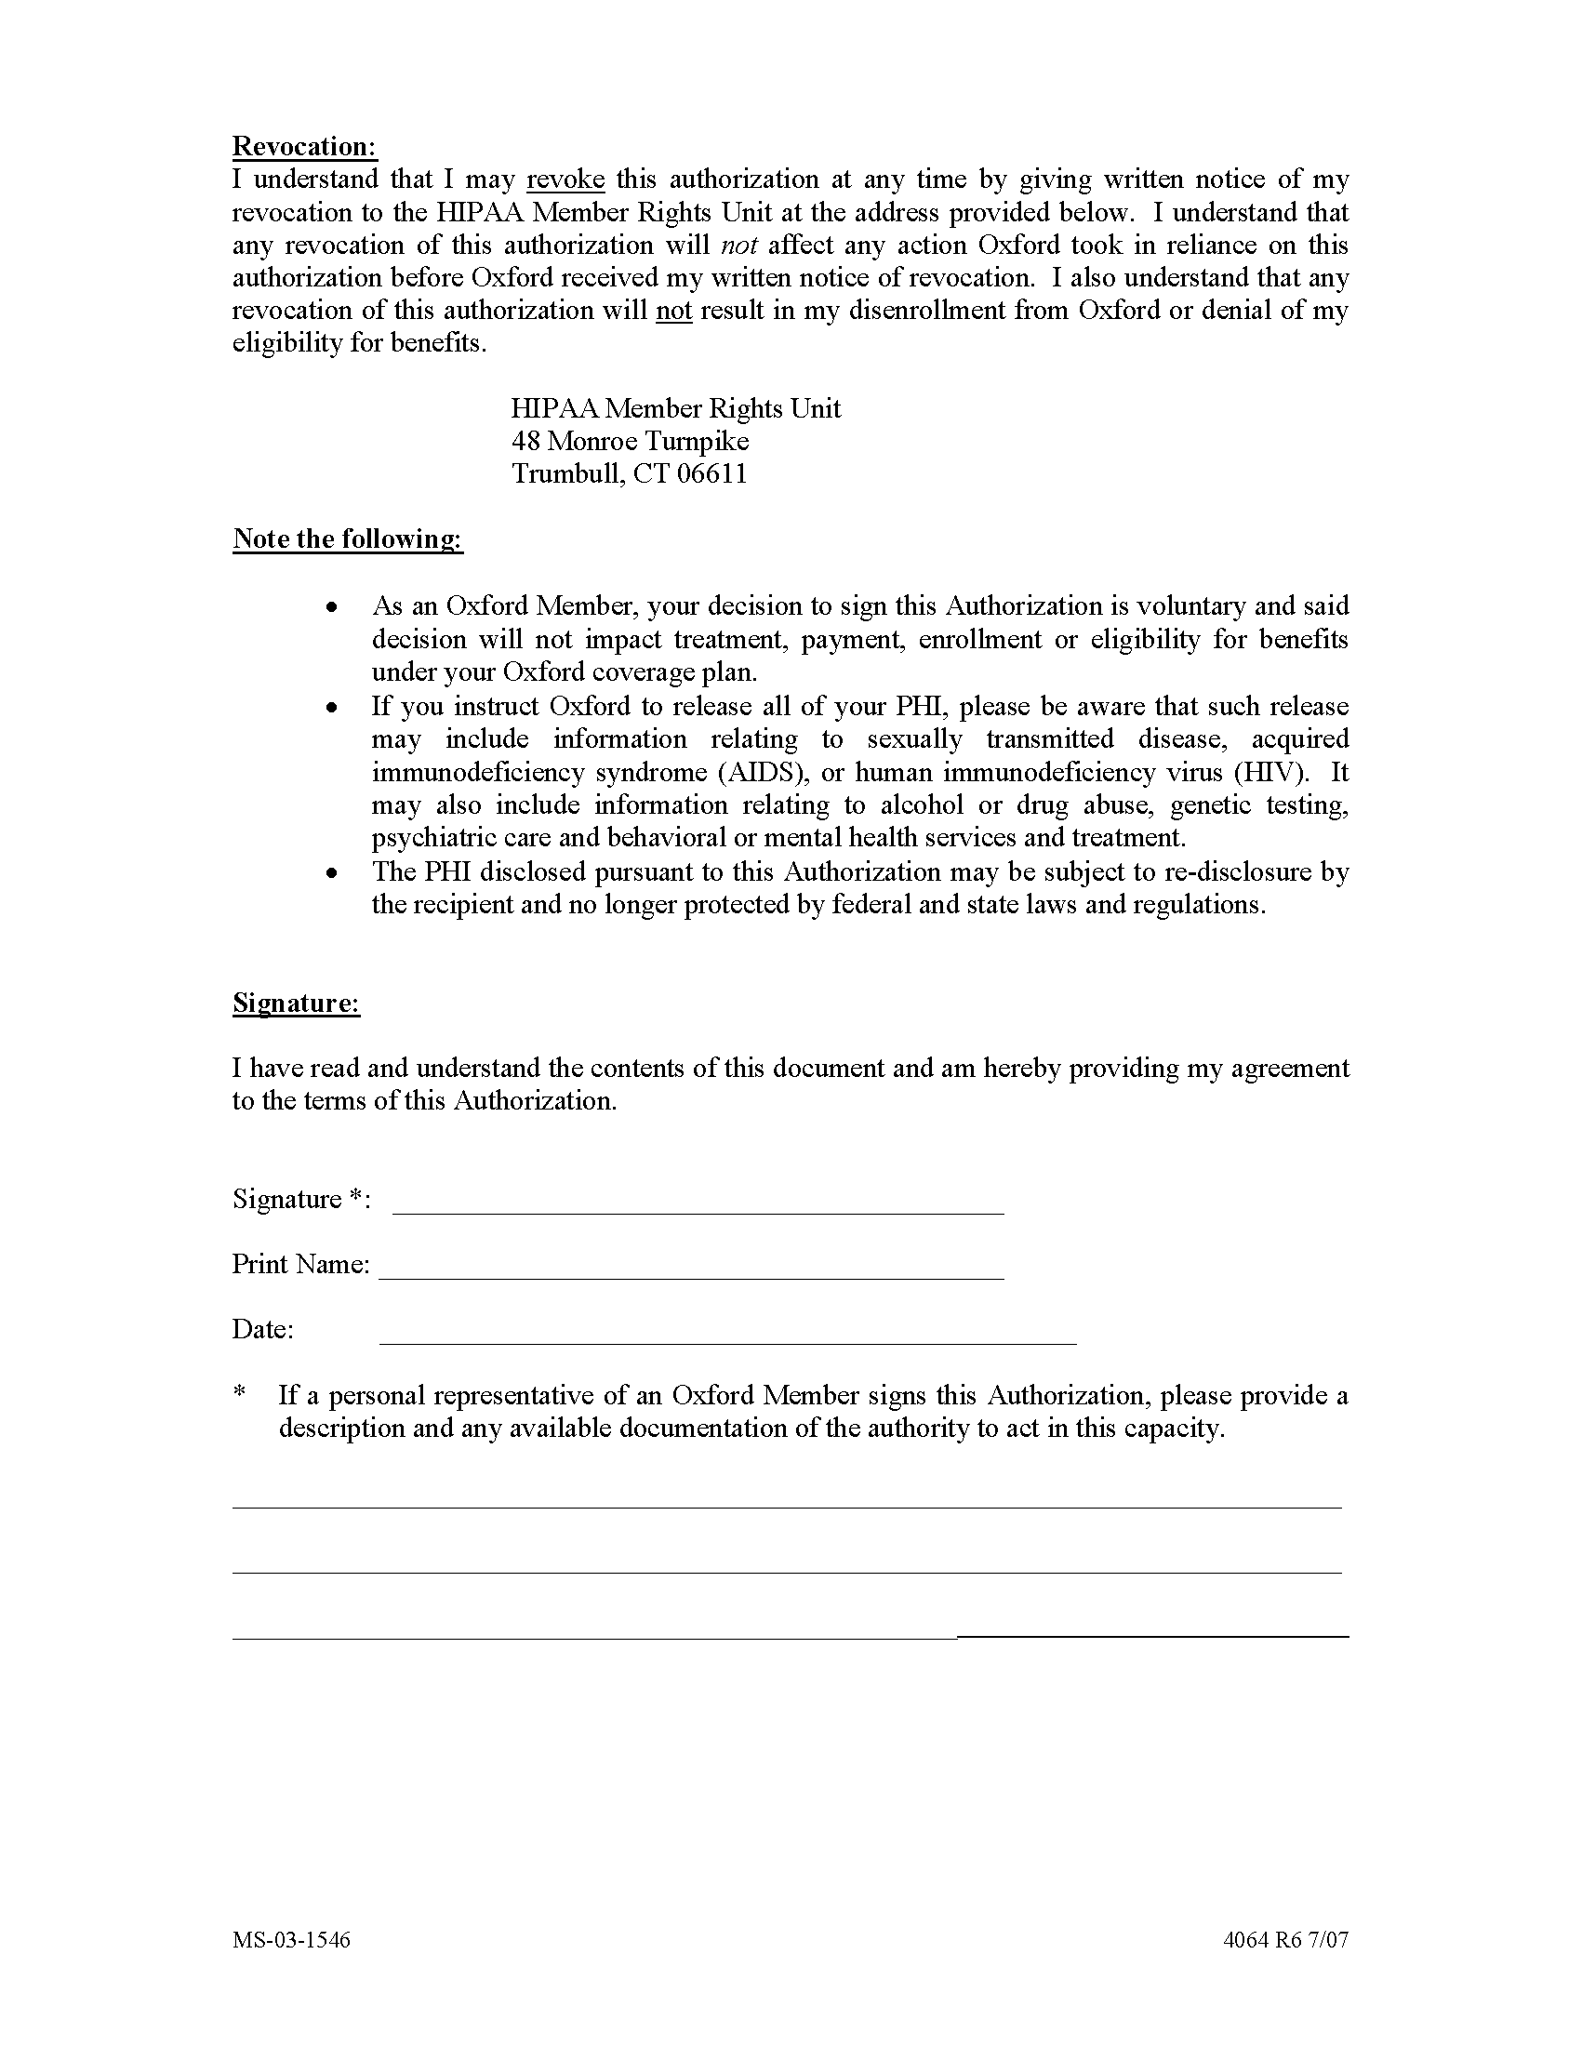
Cody Zunda, a minor
01-19228-005

